Database for Nevada Citizens

This document provides a detailed description of all citizens living in Nevada and the database containing information about all of these citizens. This database was developed for the final assignment as part of the CIT 180 coursework.

**Table of Contents**

Introduction………………………………………………………………………………………………..2

Database Model…………………………………………………………………………………………..2

Database Tables……………………………………………………………………………………….....3

Citizen Table…………………………………………………………………………………………….…3

Address Table……………………………………………………………………………………………..3

Job Table……………………………………………………………………………………...…………...3

Tax Table………………………………………………………………………...………………………...3

**Introduction**

Nevada Citizens is a database that details information about each citizen living in Nevada. Most of this information is public knowledge, but other things, such as SSID and TIN numbers, are not publicly available. Fictitious values have been generated to show information regarding taxes and jobs.

Nevada has over 3.08 million citizens who each have unique SSID’s. Each of them has an address, phone number, job, and tax information. Each of these points of information serve to identify each Nevada citizen, and they are all stored in this database.

**Database Model**

The database has four tables: Citizen, Address, Job and Tax. The key symbol indicates which attribute is the key field for the table. The relationship lines indicate which attribute is a foreign key.

* Each citizen has a unique SSID (Social Security Identification Number) and TIN (Tax Identification Number), which cannot be assigned to more than one person.
* Each citizen also belongs to an address, but multiple people can be assigned to one address.
* Each citizen can belong to a job, although their employment status can be defined as ‘Unemployed’ if they are not currently working.

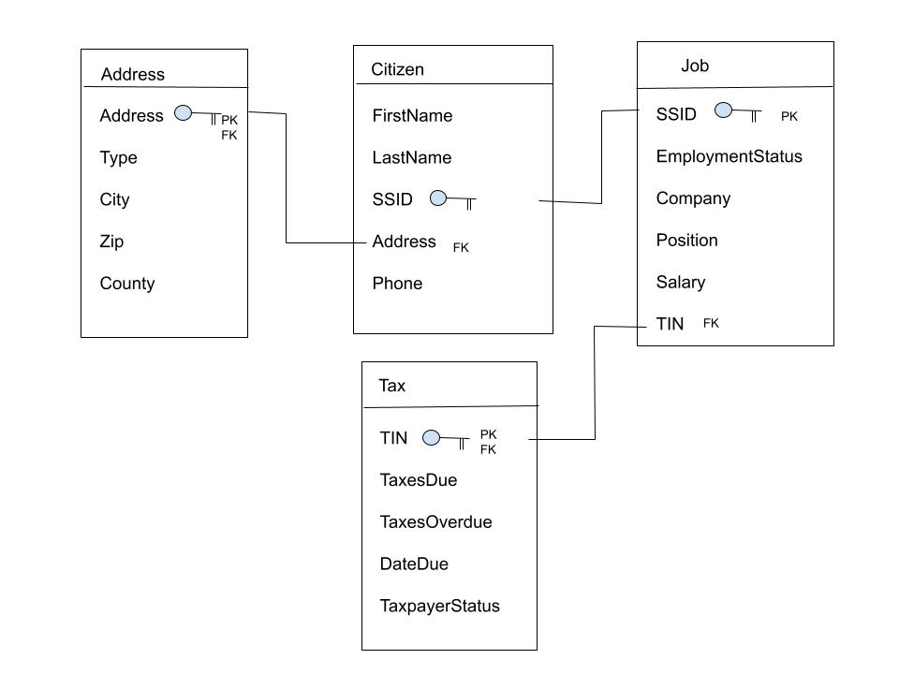

**Database Tables**

**Citizen Table**

The Citizen Table contains the information of all citizens living in Nevada. The primary key to the table is SSID, which is a number assigned to all U.S. citizens. This number is unique to each person, and no two people can have the same SSID. The table also includes the citizen’s name and phone number.

The address is also included, which is the foreign key for the address table.

**Address Table**

The Address Table contains information regarding the address of each citizen in Nevada. The primary key to the table is address, since each address automatically implies the type of residence (single-family home / apartment), city, zip code, and county in which it is located. Address is also the foreign key.

The table also includes the attributes Type, City, Zip and County. The state is not included since all citizens in the database live in Nevada and would therefore be redundant.

**Job Table**

The Job Table contains employment information for each citizen in the database. The primary key to this table is SSID, and the foreign key is TIN. If the EmploymentStatus attribute is defined as ‘Unemployed’, all attributes other than SSID can be set to N/A.

The table also includes the attributes Company, Position, Salary and TIN.

**Tax Table**

The Tax table contains information on taxes due, taxes overdue, taxpayer status, and the primary key is TIN. The TIN is unique to each citizen and no two citizens can have the same TIN. If there are no overdue taxes, the taxpayer status is ‘Good Standing’. If taxes are overdue, taxpayer status is ‘Outstanding Balance’.

This table also includes TaxesDue, which shows the amount of taxes currently due, TaxesOverdue, which shows the amount of taxes overdue past their due date, and DateDue, which shows the date when taxes are currently due.